**PROJECT REPORT ON**

***Filtering Schools for a Mentoring Program by calculating the Graduation rates***

Submitted by

Neeti Panjwani – 001382039 ([panjwani.n@husky.neu.edu](mailto:panjwani.n@husky.neu.edu))

June, 2020



**Title**

Identifying high schools from the data retrieved for a Mentoring Program by calculating and comparing the graduation rates of schools in a city.

**Abstract**

This report shows the purpose of calculating graduation rates of schools and further using this information to filter the schools that are below or above the average of the graduation rate. The data for a city will be examined and schools will be filtered. The location would be used for the mentoring program sites. The steps followed in this project are: 1. Preparing the data for analysis by querying, managing the fields, joining tables and adding data, 2. Exploring the data using the histogram for the results and finally, 3. Using this data to select/ filter the schools based on the graduation rate.

**Methodology**

1. Preparing the data for analysis

Data will be first filtered and adapted from a couple of sources.

This is how my map looks like after importing the shape file and the csv file obtained from ESRI. This map shows the schools is Chatham County, Georgia. Points represent the schools, while the layer behind represents the zone.

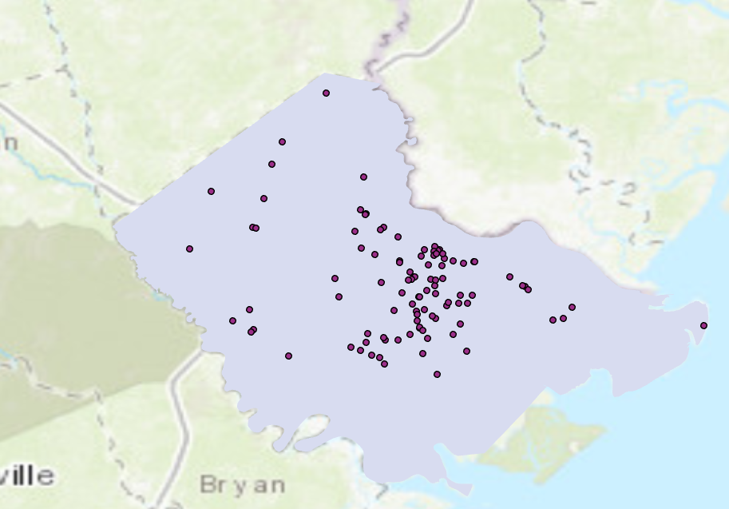

Adding a definition query:

The data contains more features and attributes than required. Therefore I have queried the schools table to filter the ‘public high schools’ from all that are present. 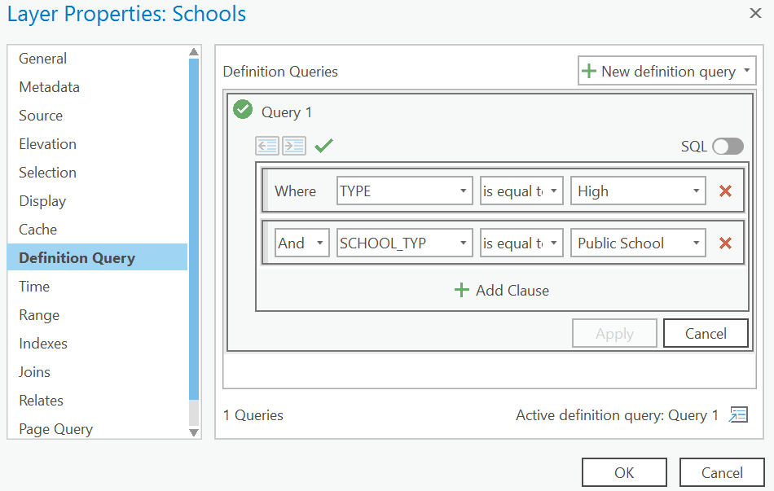

The resultant figure after filtering the schools is as follows:

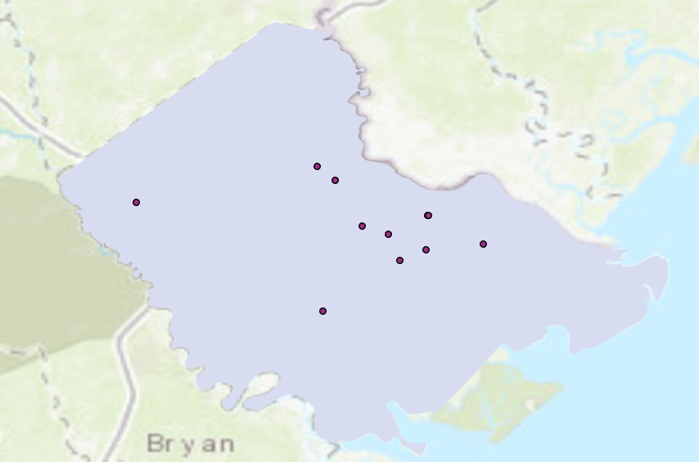

This layer only shows ‘Public High Schools’, which is important for this part of the analysis. After this step, I hid all the fields from the ‘Schools’ and ‘AttendanceZones’ tables that are not required. Now we ‘compare the two tables’ side by side:

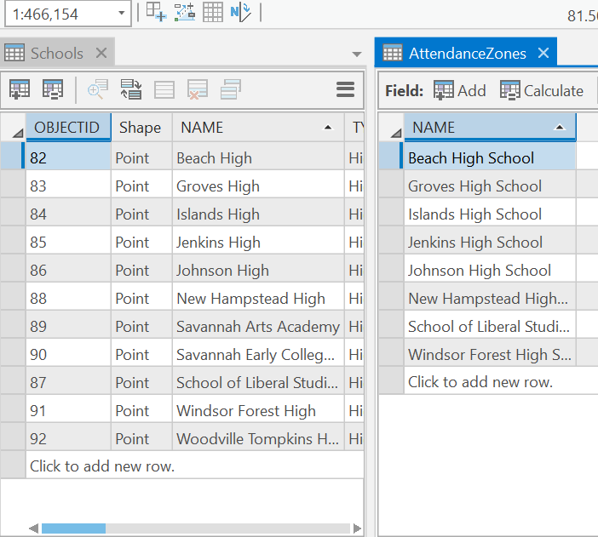

However, there are three extra schools that do not correspond to the attendance zones. These are Savannah Arts Academy, Savannah Early College (at Savannah High School), and Woodville Tompkins High / Twilight Program. These three schools draw students from across attendance zones.

Adding the Information by Joining the tables: I will use the state school ID code value to join this data to the Schools layer from the CSV file. This is nothing but ***Geoprocessing***.

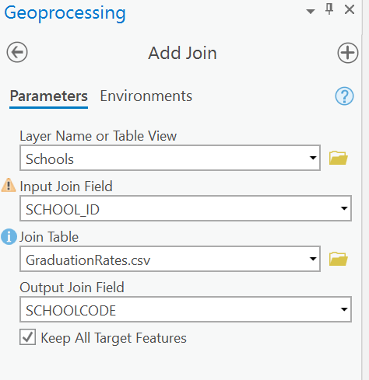

Adding fields to hold new values: 1. GradRate – The graduation rate of the schools

1. Magnet – Drawing students from single zone or across zones.
2. Under82 – Above and below the state graduation rate (82%).

Calculating the new values:

(!GraduationRates.csv.GRDNUM! / !GraduationRates.csv.GRCLASSZ!) * 100

Next, I set the Magnet field for the 3 schools outside the zone as “Yes” while the rest as “No”. Now we export this data to a new feature class.

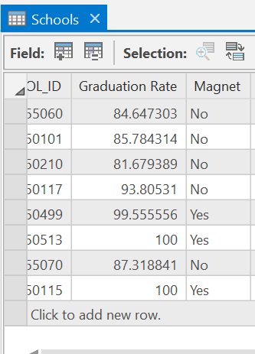

*Until now*: I have downloaded, opened, and explored the initial data for the project. I changed the fields that layers show and added new fields. Joined data to the schools from a .csv file, calculated the graduation rate, and coded schools as magnet or nonmagnet schools. I exported a new layer of just the high schools with all of the information that I have added.

2. Exploring the data:

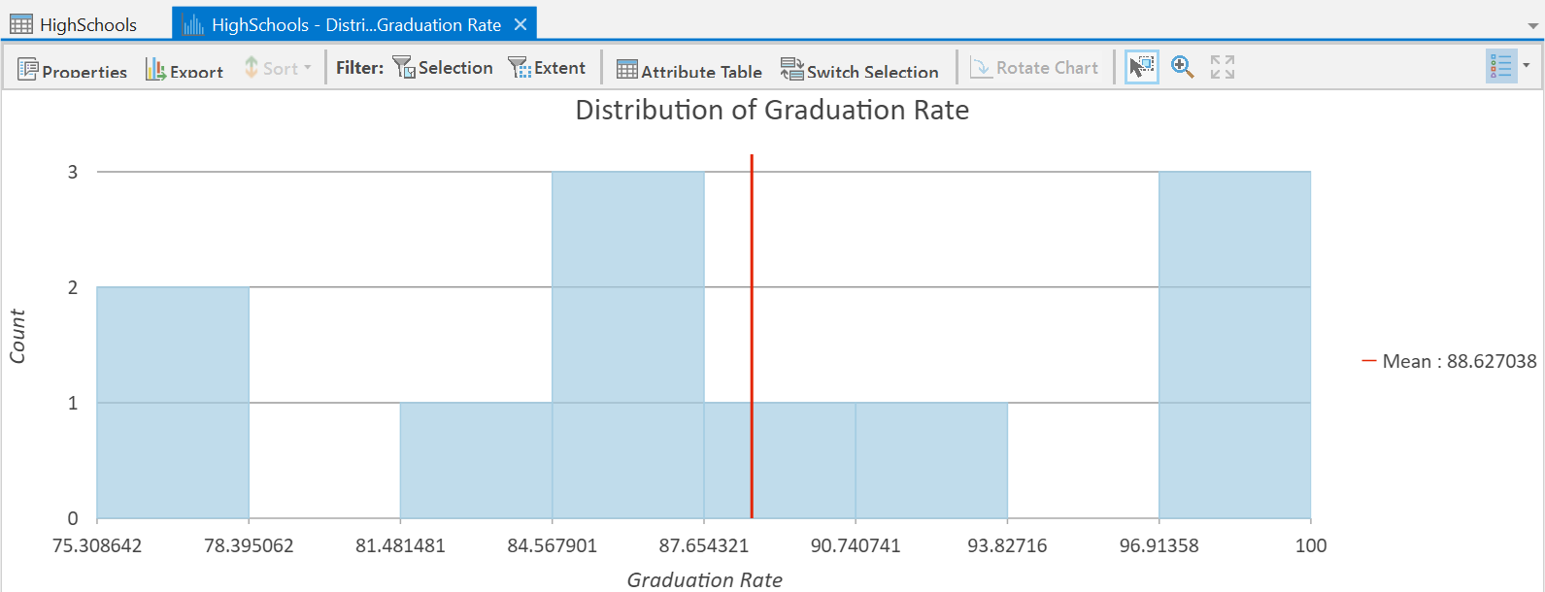

The image above shows the graduation rates.

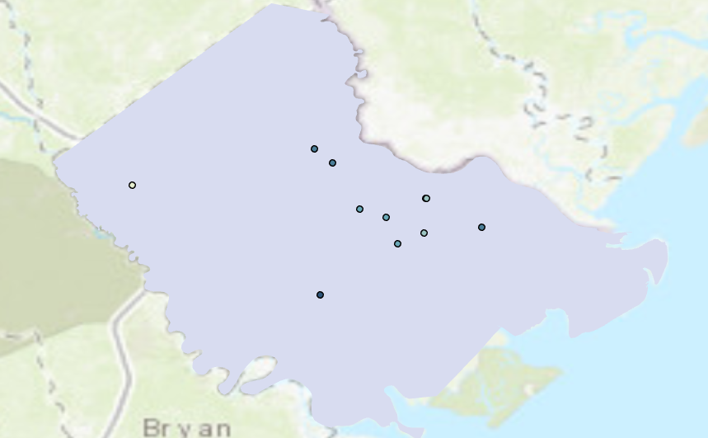

The image above shows the changed symbology for the high schools. (Graduated)

The mean graduation rate for high schools was 88.6, while the graduation rate for the state as a whole for 2019 was 82 percent. An organization wants to start the mentoring program in schools that are performing below the state average graduation rate of 82 percent.

Next, I’ll change the symbology to emphasize the schools with rates under 82 percent. Below is the map for it:

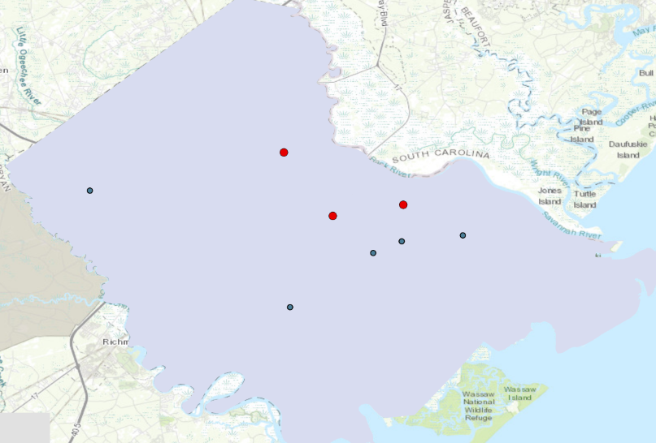

The final step is to import this to a new Layer that shows the final features:

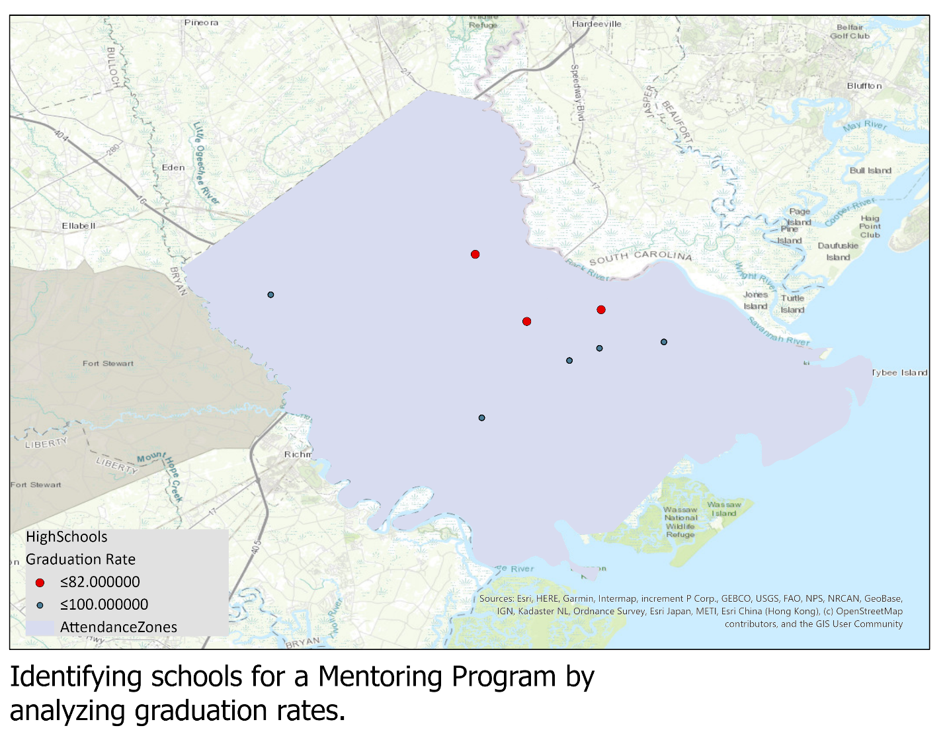

**References**

[1]. (N.A) “Identifying Schools for a Mentoring Program” Retrieved from <https://learn.arcgis.com/en/gallery/#?t=lesson>

[2]. ARCGIS Lessons Gallery Retrieved from <https://learn.arcgis.com/en/gallery/>